# SRS

Group 19

**System description**

**introduction**

- the cashier system or point of sale is a combination of hardware and software built to centralize business operations. You can store the products information where any product has a specific bar-cod and price also you can update the price at any time , delete any product information or add a new item to the system. The system support a simple mathematical calculations to help the user in making the receipts.

The system provides a selling rate for each product that helps in evaluating products and giving a feedback to owner business and also give the Total Revenue .

There is a security system for the cashier where you can inter the password wrong three times after that the alarm run. and for more security the cashier has a temperature sensor When the temperature exceeds a certain degree the alarm does.

**users**

- Dealing with the the cashier is very simple, since any one has a background on the language and the simple basics of mathematics are easy to use.

**modules**

1-Microconttroler

1.1-timer

2.1 UART

3.1 GPIO

4.1 EEPROM

5.1 C

2- LCD

3-KEY PAD

# Introduction:

## 1.1. Purpose

It’s a system that is used in shopping centers, markets malls, etc.… This system makes it easy for the managers to control the place circumstances, get regular feedback about the incomes and outcomes of the market and make the place much more secure

## 1.2. Scope of Project

* **Casher system**: System can do calculation, ability to get the price of the product by its barcode, store in the memory the current amount of money in the memory and open the locker by password hence the security is enhanced and getting feedback became easier.
* **Air-condition** **System:** System controls the temperature of the market by using sensors.
* **Security System:** Dedicates to secure place with cameras inside and outside the market and with alarm devices.
* **Doors System:** controls opening and closing the doors of the market. The main doors open by password and the internal doors open automatically using sensors that can detect people motion.

## 1.3. Overview of Document

* The next chapter, the system Description section, of this document gives an overview of the functionality of our project. It describes the informal requirements and is used to establish a context for the technical requirements specification.
* The third chapter, system users section, of this document gives the user role descriptions and is written primarily for the developers and describes in technical terms the details of the functionality of the product.
* The fourth chapter, system modules section, of this document Provide module description. Use block or context diagram to illustrate external and sub-modules. Use activity diagram, state machine diagram, data flow diagrams to illustrate module operations.
* The fifth chapter, system functions section, of this document Provides function description. And function of inputs. And function of outputs. And function required conditions to work. And new conditions after work
* The sixth chapter, system models section, of this document makes only mandatory diagram to illustrate overall system interaction or to explain complex scenarios
* The seventh chapter, non functional requirements section, of this document gives Non functional security, usability, technology, performance, development, delivery and operation requirements description
* The eighth chapter, domain requirements section, of this document Explains domain requirement or constrain.
* The ninth chapter, system interface section, of this document provides with user interfaces, communication interfaces, hardware interfaces, and any others interfaces.
* Every section of the document describe the same software product in its entirety, but are intended for different audiences and thus use different language

# 1.5. References

1) *ANSI/IEEE Std 830-1998, IEEE Recommended Practice for Software Requirements Specifications*

s

(2)*ANSI/IEEE Std 1233-1996, IEEE Guide for Developing System Requirements*

*Specifications*

1. [*http://www.softwareengineering-9.com/*](http://l.facebook.com/l.php?u=http%3A%2F%2Fwww.softwareengineering-9.com%2F&h=bAQHQJ_iq&enc=AZM5qzL1suvwfnQtEREHBeWKO1CVupuW6lk4NB6fOESa3Jd6ev1uR9X9PqEZObdWkoYfT7wocstj_K6CgG1AhXZy4AfeFzGcNtrrbliFfEOY5JTXGiFIxchlxhz22HAa_tGqgSw9qztHQbYnPAlbVF0q&s=1)
2. *srs_example_2010_group2*

# System Users:

System’ users are companies and entities rather than individuals . It is installed for a hypermarket , supermarket , or a shopping center . Its users are on three levels:

* Sales level
* Security level
* Managers level

Each of these three types of users has different use of the system so each of them has their own requirements.

## Sales Level:

The company employs many sales people . Those are people who interact with clients to manage transactions for the different items the company is selling

They handle calculations ,set their own password for cash locker and use it when they want

They can open cash locker using their passwords , but locker will close again after a certain amount of time for more security . If password is entered wrong for three consecutive times , locker automatically locks and becomes unavailable for cashier’s password and requires higher permission to open again

## Security Level:

For the sake of company’s items security , the company employs a security team . This team watches for alarms or emergencies , and have control over the doors of the place .

## Managers Level:

Managers can watch for revenues , income of the day , how much money this and that cashier have and inventory contents . They basically get feedback at anytime from any team within the company .

They also set prices for items and store them

**System Modules**

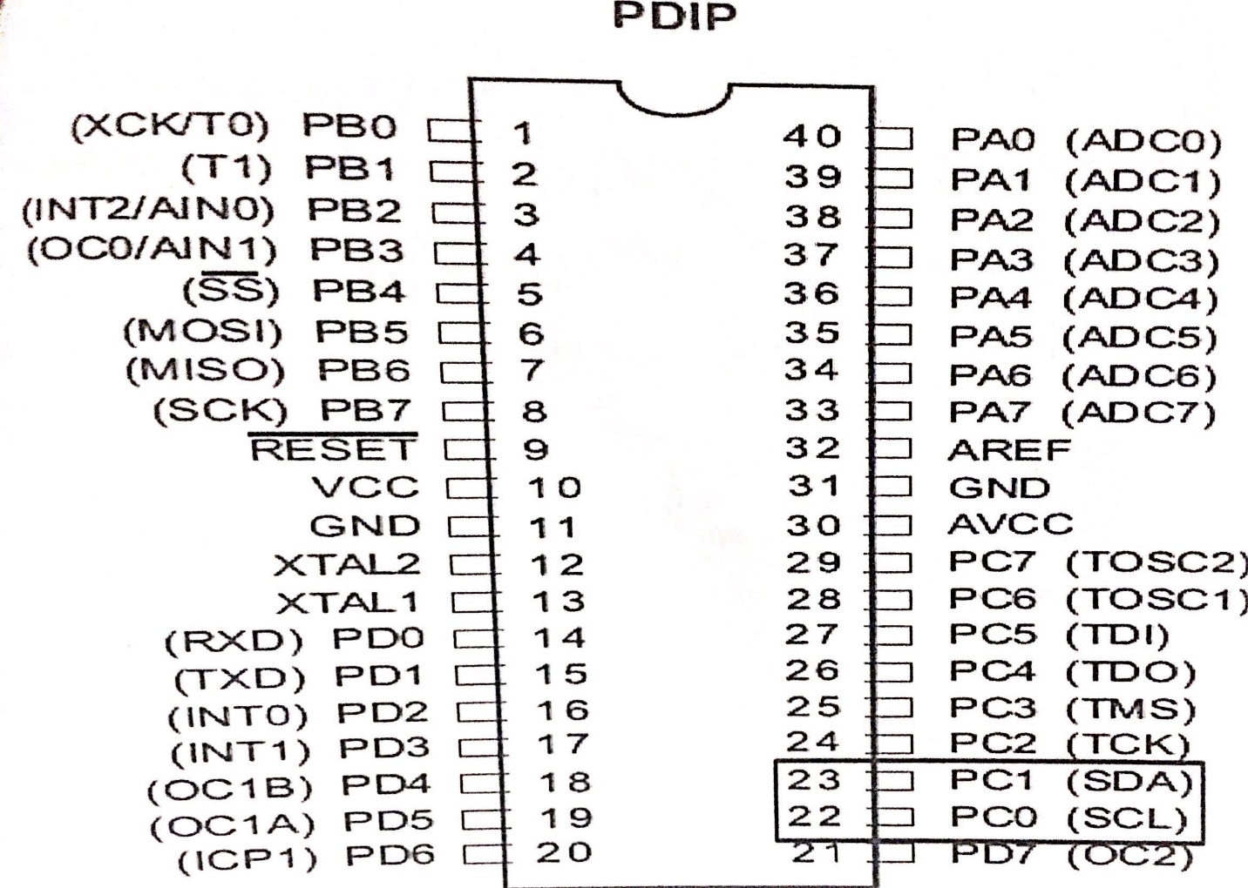**Module I2C**

* Inter Integrated Circuit (I2C) and also called two wire interface (TWI) since it uses only two wires for communication.
* Multi-Master Multi-Slave Bus.
* In I2C protocol communication always started by the master and in the case of multi-master, only one master have the ownership of the bus
* It widely used in fast and short distance communication like communicate between Microcontrollers and Sensors, EEPROM and LCD.
* The device that initiates a transaction on I2C bus is termed the master. The Master normally controls the clock signal. A device being addressed by the master is called a slave
* 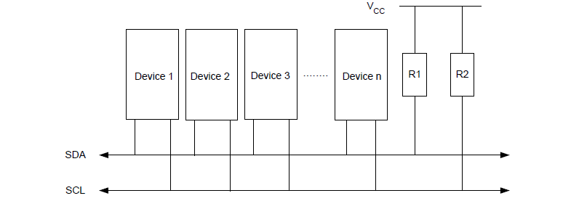In I2C, every data which is transmitted over the SDA line must be 8-bit longs. It is very important to remember in I2C that data bit is always transmitted from the MSB and we can send or receive any number of bytes in I2C between the start and stop condition. In I2C, one bit is always transmitted on every clock. A byte which is transmitted in I2C could be an address of the device

Usage in our Project :

It will be used to connect between the external EEPROM and the

Microcontroller. The controller will exchange information with the EEPROM

using I2C module.

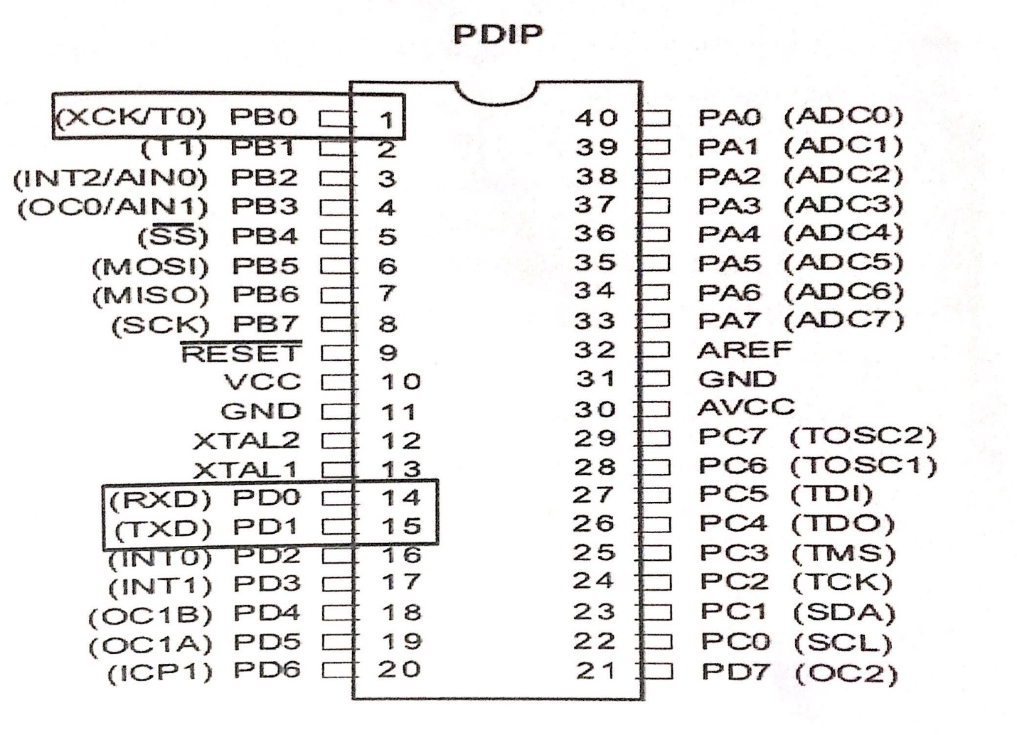**Module USART**

* Universal Synchronous Asynchronous Receiver Transmitter.
* Serial Full Duplex Communication. Both transmission and reception can occur at the same time
* 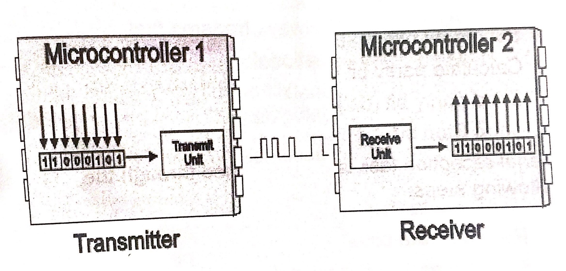The USART uses two I/O pins to transmit and receive serial data.
* Usage in our Project :

To communicate with the other microcontrollers.

EEPROM

EEPROM (also E2PROM) stands for Electrically Erasable Programmable

Read-Only Memory and is a type of [non-volatile memory](https://en.wikipedia.org/wiki/Non-volatile_memory) used in computers,

integrated in [microcontrollers](https://en.wikipedia.org/wiki/Microcontrollers) for [smart cards](https://en.wikipedia.org/wiki/Smart_card) and [remote keyless system](https://en.wikipedia.org/wiki/Remote_keyless_system), and

other electronic devices to store relatively small amounts of data but allowing

individual bytes to be erased and reprogrammed.

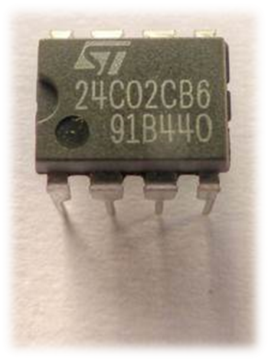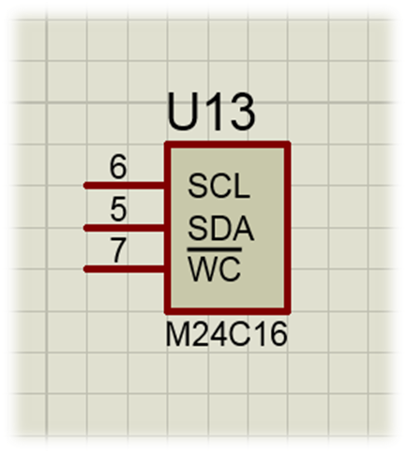

Usage in our Project :

It will be used to store the password of the locker and the doors. Also , it will

be used to store the prices of the products. Each product will have its own

barcode and price saved on the EEPROM. It will communicate with the

controller using the I2C module.

KEYPAD

This 16-button keypad provides a useful human interface component for

microcontroller projects. Convenient adhesive backing provides a simple way

to mount the keypad in a variety of applications.

Key Features:

* Excellent price-performance ratio
* Easy communication with any microcontroller

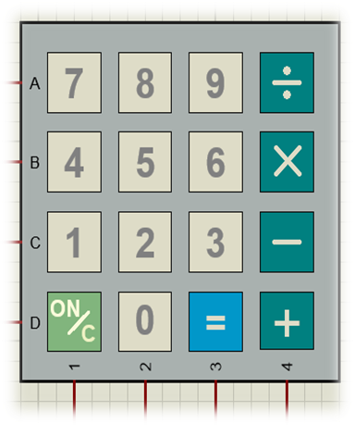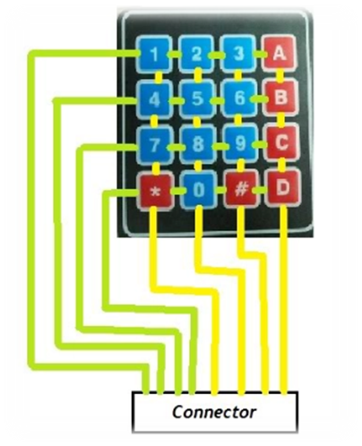

Usage in our Project :

It will be used as an input tool, customer can set or enter password through

this device. Also, the barcode is entered through this keypad. Can be an

input for the data to make some calculations on.

The entered data is processed by the microcontroller , and then it's wither

stored or used to make decisions.